# Assignment 5 – Group 3

In this assignment we will introduce 3 L-Systems that produce:

* a plant
* a tree
* and a bush/weed

We will provide detailed explanations on the axioms and production rules for each of the systems.

## Wild Hay

The code for this system is divided into the following:

* **Axiom**: X
* **Production rules**:
  + X - FYYF[+FFXX][-FFXX]
  + Y – (Stochastic rule)
    - 50% F
    - 50% X
* **Turtle Parameters**:
  + Length - 5
  + Width - 1
  + Angle – 20

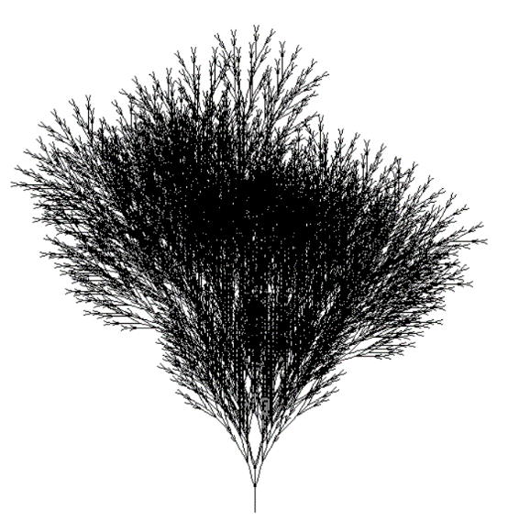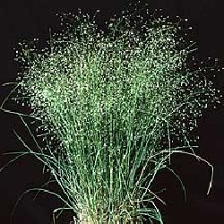

Figure – Left: Our wild hay. Right: A wild grass plant native to Utah.

For this L – System the axiom the rules we have thought of either branch the shape into two sub branches ([+FFXX][-FFXX]) or stochastically introduce an extra branch or increase the branch length (Y – 50% X or 50% F).

For the turtle parameters we left the length and width untouched but we have reduced the angle from 25 degrees to 20 to achieve a more dense shape.

## Pampas Grass

The code for this system is divided into the following:

* **Axiom**: [X+X]
* **Production rules**:
  + X – F[BXA]F [BXA]
  + F – FA
  + A – (Stochastic rule)
    - 60% F[+FX]
    - 40% F[FX]
  + B – (Stochastic rule)
    - 80% +
    - 20% F
* **Turtle Parameters**:
  + Length - 7
  + Width - 1
  + Angle – 15

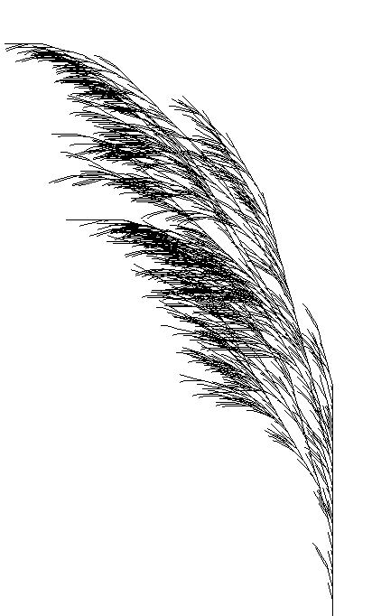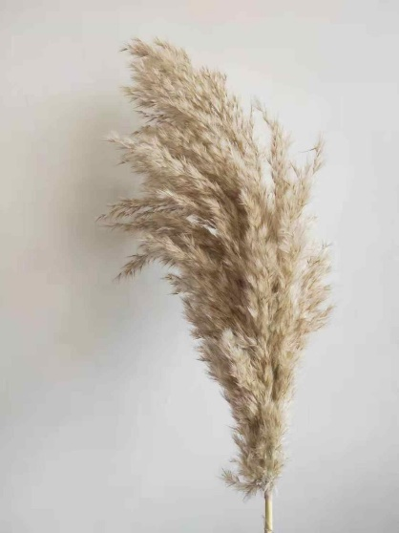

Figure – Left: Our pampas grass L-System. Right: Actual pampas grass

Here we emulated the flow of wind by adding a stochastic rule and also modifying the axiom to make the turtle turn left. By providing this randomness we can emulate (albeit with low accuracy) wind affecting the plant overall and also we can have a few branches not affected. That way our plant can have slope to the left and also grow upwards.

## Olive branch

The code for this system is divided into the following:

* **Axiom**: X
* **Production rules**:
  + X – F[YX][YX][XYX]FX
  + F – FF
  + Y – (Stochastic rule)
    - 5% +++
    - 45% +
    - 45% -
    - 5% ---
* **Turtle Parameters**:
  + Length - 5
  + Width - 1
  + Angle – 10

We wanted to add a small probability to increase the angle so that some branches diverge more from the rest. We also added 3 branches in the productive rule, with one of them having double recursion on rule X. This enabled us to create some denser and some narrower branches.

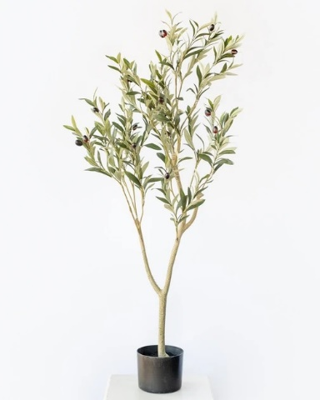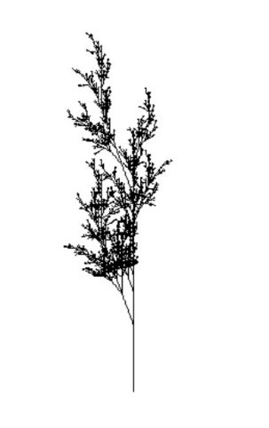

Figure - Left: A young olive tree. Right: Our olive tree L-System